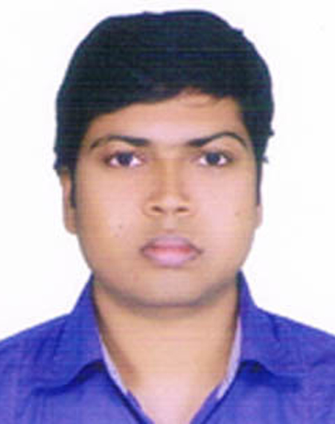
BIDHAN KUMAR DAS
C/o. Ashutosh Das
Vill- Pabla Bonikpara (kali-Mondir), P.O- Daulatpur,
P.S- Daulatpur, Dist-Khulna.
Email- bidhandas14@gmail.com
Mobile:- 01613808088

CAREER OBJECTIVE

To serve my organiZation with the efficient discharge of duties and responsibilities in order to attain its goal.

EDUCATIONAL QUALIFICATIONS

Institution | Year of Passing | Degree/Certificate | Area of Specialization | Class/Division/  CGPA/(Marks)
Govt.B.L.College Khulna | 2013 | Masters of Business Studies (M.B.S) | (Accounting) | 1st Class(71.4%)
Govt.B.L.College. Khulna | 2012 | Bachelor of Business Studies (B.B.S) | (Accounting) | 1st Class(64.35%)
Daulatpur College. | 2007 | Higher Secondary Certificate (HSC) | Commerce | 3.90 G.P.A
Mohsin Govt. High School. | 2005 | Secondary School Certificate (SSC) | Commerce | 4.06 G.P.A

WORK EXPRIENCE
Total Year of Experience : 2.6 Year(s)
Information and Documentation Officer ( April 1, 2019 - Continuing)
Christian Service Society (CSS)
Department: Education Sector (Accounts)
Duties/Responsibilities:
To maintain account in Oracle application server form service software ,Cash receipt,prepare daily collection sheet,Maintain volume book,Bank deposit,Prepare due list for clients ,Give information to every kinds of clients,Put information in online software and filing all important documents.
Executive ( July 1, 2018 - December 30, 2018)
Express Systems Bangladesh Limited.
Department: Finance & Accounts
Duties/Responsibilities:
To maintain account in Erp posting,Truck road cost & fare calculation, ,Banking,Cheque management , Salary Disbursements,Bill Vouchering,Inventory Maintain,to ensure goods receiving and delivery process,Labor payment, Petty Cash Handle .

SELF-APPRAISAL
- Ability to cope up with different situation.
- Capable of learning quickly the necessary details of work.
- Co-operative & Innovative.
LANGUAGES

- Excellent command over Reading, Writing. & Speaking in English as well as in Bengali.
- High level of Interpersonal Communication Ability.

COMPUTER LITERACY

- Application Packages : Most of the Windows based packages like Office 2010 & XP with MS Word, Excel, Access, and Power Point.

- ICT Course : 1 Year Under National University.

BIOGRAPHY

Father’s Name : Ashutosh Das
Mother’s Name : Purnima Rani Das
Date & Place of Birth : 14th November 1989, Khulna, Bangladesh.
Permanent Address : Pabla Banikpara ( Kali-Mondir),Daulatpur,Khulna. Nationality : Bangladeshi.
Marital Status : Single.
Religion : Sanatan.
Height : 5.6”
Weight : 63.5 kg
REFEREE

- Professor Ashis Kumar Datta( Retired)
Govt. B.L College , Khulna.
Cell : 01710851587.

- Ripan Kumar das
Accounts Officer
Beximco pharma ltd.
Cell :01727-224688.

BIDHAN KUMAR DAS

